For 75th D-Day anniversary, late Montreat mayor's machine-gunner days honored in Normandy
Jennifer Bowman, The Citizen-TimesPublished 5:00 a.m. ET June 6, 2019
CONNECTTWEETLINKEDINCOMMENTEMAILMORE
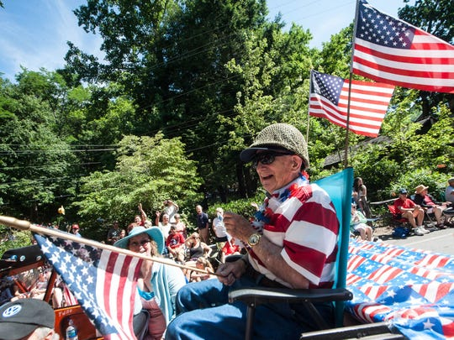Buy Photo
Andy Andrews greets the crowd at the Montreat Fourth of July parade. Seventy years ago, Andrews spent the holiday in France, less than a month after landing on Omaha Beach during the D-Day invasion that led to the end of World War II. (Photo: Bill Rhodes, Citizen-Times photo)
Doug Orr was traveling the beaches of Normandy in a tour bus, passing banners bearing the photographs of World War II heroes, when he spotted a familiar face.
"Suddenly, there's Andy Andrews," said Orr, a Black Mountain resident and former Warren Wilson College president. "They were all, as you could see from the photographs, in their uniform as young soldiers. And I knew Andy had been in the Omaha landing, so it had to be him."
On June 6, 1944, some 160,000 Allied soldiers assaulted the Nazi-occupied French beaches of Normandy. But among what Orr estimated to be a couple dozen banners commemorating D-Day's 75th anniversary this year was Andrews, a Tennessee boy who went on to fight in the war and later made his mark in the Western North Carolina mountains.
His daughter, Sarah Andrews Murray, told the Citizen Times she was unaware her father was one of those honored in such a way for the anniversary. But in a phone interview June 3, Murray sounded elated — and amazed a local had spotted his photo.
"I was always very proud to introduce myself as Sarah Murray, Andy Andrews' daughter," she said.
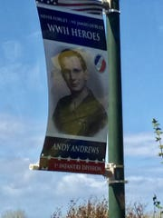
A banner at Omaha Beach displaying the photo of late Montreat Mayor Andy Andrews was spotted by Western North Carolina resident Doug Orr while visiting Normandy in April 2019. Andrews fought at Normandy as a machine-gunner in the U.S. Army. (Photo: Courtesy of Doug Orr)

Andrews, a D-Day machine-gunner
Andrews, who died three years ago, was part of the 16th Infantry of the 1st Division when he arrived with the third wave at Omaha Beach. He was assigned as a squad leader of a 30-caliber heavy machine gun.
Andrews recalled to the Charlotte Observer in 2014 that he remembered boarding a troop ship at midnight. There were 5,000 soldiers on board and Andrews said he could barely see.
When he moved onto a Higgins boat, "I slid in puke," Andrews said in an interview with the Citizen Times. Then a soldier behind him vomited on the back of Andrews' shirt during the ride to shore.
By the end of June 6, the Americans had suffered 2,400 casualties at Omaha, long known as the costliest part of the D-Day invasions.
Murray said her father was in 17 of the 23 worst WWII battles in Europe, "one after the other." Andrews walked for the most of the way from Normandy to Czechoslovakia, and lived outside for 10 months.
In total, he earned four Purple Hearts and four Bronze Stars.
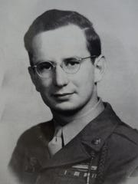
Andy Andrews enlisted in the Army after high school. He served in Gen. George Patton’s army. (Photo: Special to the Citizen-Times )
In 2016, Montreat College professor William Forstchen told the Black Mountain News that he twice traveled with Andrews to Europe. On one of those trips, he said, Andrews told a story of coming under machine gun fire during the last weeks of the war in Germany.
When he was about to throw a grenade, the machine gun went silent and he thought he heard children crying. Andrews crawled to the pit and saw three little boys inside.
"What he did next — these boys had been trying to kill him 30 seconds earlier — he had a stick of gum in his pocket and tore it in three pieces and gave it to the boys," Forstchen said. "Seconds later the boys were in his arms, sobbing. He and the men in his unit carried them back to their village to their parents."
Murray said her father, who grew up during the Great Depression and was drafted into the war immediately after high school, was like others his age.
Get the News Alerts newsletter in your inbox.
Get alerted to the latest stories to stay on top of the news.
Delivery: Varies
Your Email
"By the time they were in their early 20s, they lived through what most of us can't even recognize," she said. "(My dad) did embrace that. He did talk about his experiences, the good and the bad."

His impact on WNC
Andrews left the Army shortly after the war ended. He'd return to Tennessee, where he attended the University of Chattanooga and King College in Bristol. He graduated in 1949 from the Presbyterian School of Christian Education in Richmond, Virginia.
In Montreat, Andrews was a longtime member of Christ Community Church. He was twice elected mayor, served on its town council for 20 years and was a Montreat College trustee for more than 15 years.
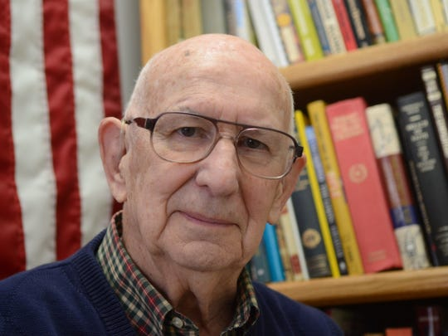
Andy Andrews, retired from Montreat Conference Center, was part of the third wave in the Normandy invasion. He was a private assigned to fire a .30-caliber machine gun. (Photo: Jon Ostendorff , jostendo@gannett.com )
He was executive director of the Black Mountain-Swannanoa Chamber of Commerce, president of the Asheville Tourism Association and director of the Montreat Conference Center, along with stints at several other organizations.
Bob McMurray, the chamber's current director, said Andrews was known to visit Highland Farms, where Hellon, his wife of nearly 60 years, lived after being diagnosed with dementia until her death in 2008.
The couple had two children: Murray and Al Andrews.
Andy Andrews died in May 2016 at age 92, while he was living at Highland Farms. He's buried at the Western Carolina State Veteran's Cemetery in Black Mountain.
Bob McMurray said Andrews loved Montreat. He said he played an instrumental role in acquiring the building that became the visitor's center and now is named in Andrews' honor.
"It's quite amazing," McMurray said of Andrews being honored in Normandy this year. "That shows what a small world it is. No one knew that here."
Andrews visited Normandy several times, though Murray never accompanied him. It was too difficult for her to know her father experienced that, she said.
But Andrews spoke openly about his service, even more so as he got older. Murray said she continued to learn details about her father's time in the war in her adult years.
Andrews went on to speak at veteran's events and local schools about his WWII experience. He told his daughter he thought of the war daily, but saw his own life as full of blessings.
"I think it was important for him to know what they went through for us," Murray said. "And I think what he wanted to tell kids and us today is what a wonderful life we have of peace and freedom.
"But boy, it came at a price. And I think that he did use that terrible experience to make a better life for himself."

The 75th anniversary
The D-Day invasion was the largest by air, land and sea in history and is credited with changing the course of the war and ultimately pushing Nazi troops back to Germany. The U.S., Britain and Canada used more than 5,000 ships, 11,000 airplanes and 150,000 soldiers in the surprise attack.
Following the mass casualties of D-Day, the battles of Normandy continued for roughly three more months, until Allied troops had pushed all the way to the Seine River and liberated Paris from Nazi control. Less than a year after D-Day, Adolf Hitler committed suicide and Nazi Germany surrendered.
More: World War II D-Day: Five things to know on the 75th anniversary of the Normandy landings
The head of the American Battle Monuments Commission, which oversees the American-run cemetery in Normandy and is leading the planning, told USA TODAY that officials expect between 12,000 and 15,000 at the 75th anniversary ceremony. ABMC Secretary and retired Army Maj. Gen. William Matz said that will include more than 100 World War II veterans.
"It’s going to be a huge event, a huge ceremony," Matz said. "This is probably going to be maybe the last five years’ anniversary where we really have a fairly good number of World War II and actual D-Day vets."
About 496,777 of the 16 million Americans who served in WWII were still living as of September 2018, according to projections by the U.S. Department of Veterans Affairs. An estimated 348 WWII veterans die every day in the U.S.
A decade from now, it’s estimated that fewer than 20,000 WWII veterans will remain.
Orr said his recent visit to Normandy, including the American cemetery where there are some 9,000 veterans laid to rest, was moving.
"It's the end of an era," Orr said, "and I think that's one reason why the Normandy story is touching so many, too. Because everybody knows it's kind of the last one."
He added, "Then to see Andy Andrews' name on there, I thought folks back home really ought to know about that."

